8-1 Final Project Milestone Four: System Design

Christopher Gray

IT 510: Advanced information Technology

Southern New Hampshire University

Professor Corley Hughes

1. **Systems Design**: The essential principle underlying the design of any distributed system is system design. System design is described as the process of developing an architecture for various system components, interfaces, and modules and supplying matching data useful in implementing such parts in systems (geeksforgeeks.org, n.d.).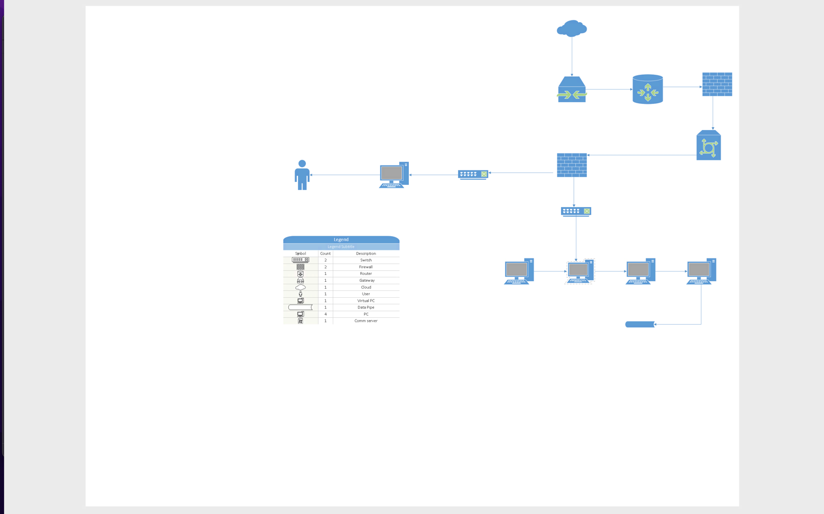
   1. **Specifications:** A system requirements specification presents general information on the requirements of a system, which may include both hardware and software, based on an analysis of business needs (perforce.com, 2023). The system requirements for Attaway Airlines are intended to outline the hardware and software components required to successfully run and support the airline's computer systems. These criteria guarantee that the technological infrastructure fulfills the basic standards required to enable the systems' expected functionality and performance.

The minimum specifications for computer hardware components such as the CPU, RAM, monitor, keyboard, mouse, hard disk, and CD drive are specified in the hardware requirements. These criteria guarantee that Attaway Airlines' computers have enough processing power, memory, storage capacity, and peripheral devices to accomplish the needed activities and applications. Attaway Airlines can ensure that their computer systems are properly equipped to meet the needs of their business processes, support the required applications, maintain data integrity and security, and provide a reliable and efficient computing environment for their employees and customers by defining these requirements.

|  |  |
| --- | --- |
| **Minimum Hardware Requirements:** |  |
|  |  |
| **Hardware Component** | **Specifications** |
| Processor | Pentium III @500 MHz or above |
| RAM | 512 MB |
| Monitor | 15" |
| Keyboard | Standard |
| Mouse | Optical |
| Hard Disk | 250 GB |
| CD Drive | LG52X |
| **Software Requirements:** |  |
|  |  |
| **Software** | **Version/Compatibility** |
| Operating System (OS) | Windows 2000 or above |
| Microsoft Office Access | Version 2000 or above |
| Oracle | Version 8 or above |
| Microsoft Office Word |  |
| Microsoft .NET Framework |  |
| Java SE |  |
| Android SDK |  |
| Database Server | MS SQL Server 2012 |

**Data Design:**The initial design activity is data design, which results in a less complicated, modular, and efficient program structure. During the analysis step, the information domain model is translated into the data structures required for software implementation. The data objects, properties, and relationships illustrated in entity relationship diagrams, as well as the information contained in the data dictionary, serve as the foundation for data design activities (Thakur, 2013). Attaway Airlines' data design demonstrates how data is structured, organized, and stored within the system. The database structure, data models, tables, relationships, and data manipulation tools are all included. The data design guarantees that data is recorded, stored, and accessed properly to support business operations and system functionality. It covers the needs for data integrity, consistency, security, and data access. Data integration and data interchange with other systems or external organizations are also considered in the data design.

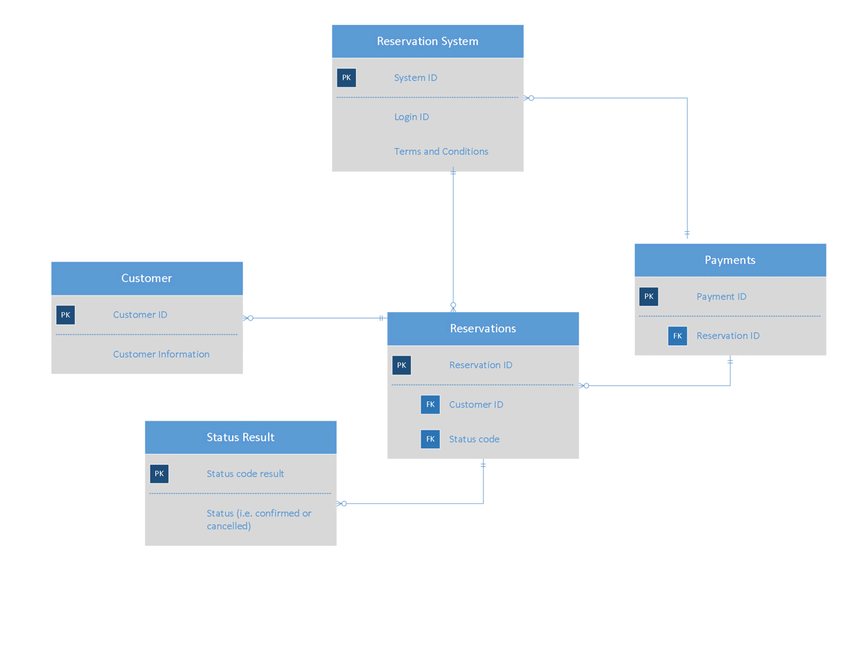

* 1. **User Interface Design:**The goal of user interface design is to provide an intuitive and user-friendly interface for system interaction. It includes creating a visual layout, navigation, and interactive components to improve the user experience. Visual design, layout and navigation, information architecture, interaction design, usability and accessibility, consistency and branding, and user input and testing are all important considerations. The objective is to build a visually beautiful, user-friendly interface that helps users to quickly navigate, complete tasks, and achieve their goals. User Interface (UI) Design is concerned with predicting what users may need to accomplish and ensuring that the interface has features that are simple to access, understand, and utilize in order to assist those activities. UI combines elements of interface design, graphic design, and information architecture (Usability.gov, 2023).

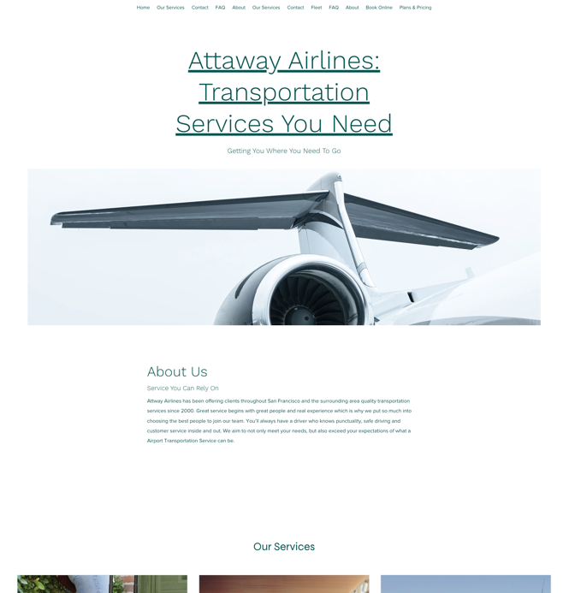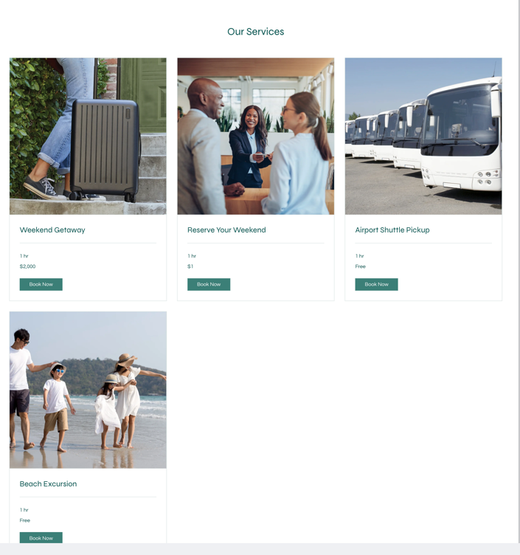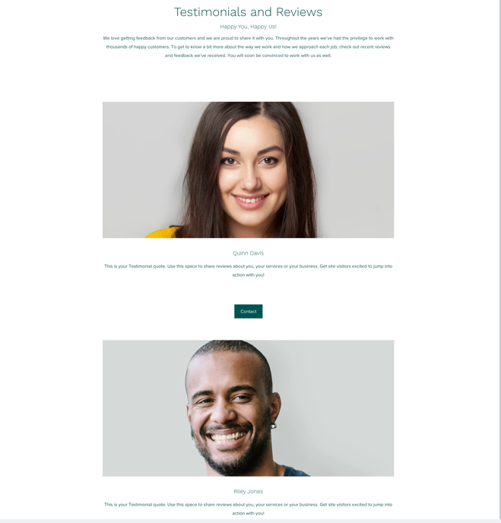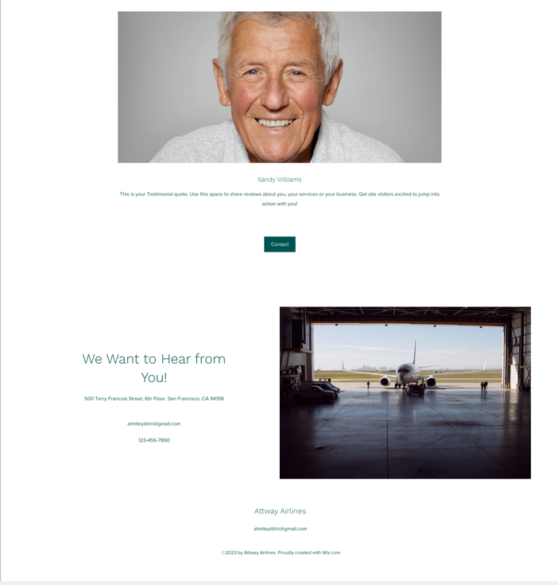

* 1. **System Architecture:**A system's architecture reflects how it is utilized and so evolves as the system is used (Interviewbit.com, 2022).

1. Corporate Organization and Culture: The system design takes into consideration Attaway Airlines' organizational structure and culture. It considers how various departments and teams coordinate and interact with the system. The design should be compatible with the company's organizational structure, communication routes, and decision-making procedures.
2. Enterprise Resource Planning (ERP): To combine and simplify multiple corporate processes such as finance, human resources, operations, and inventory management, Attaway Airlines may deploy an ERP system. The system design should support the modules of the ERP system and allow smooth data flow across departments.
3. Total Cost of Ownership (TCO): The total cost of ownership, including hardware, software, maintenance, support, and training, should be included in the system architecture. It tries to save costs while maintaining the system's efficacy, dependability, and scalability throughout its lifespan.
4. Scalability: To handle future expansion and changing business demands, Attaway Airlines need a scalable system design. To accommodate rising data volumes and user needs, the design should allow for simple expansion of infrastructure such as servers, storage, and network resources.
5. Attaway Airlines may need to link its system with external partners such as travel agents, payment gateways, and other airlines. To facilitate data interchange and interoperability, the system design should offer smooth integration via defined interfaces, APIs, or middleware solutions.
6. Security is an important part of system architecture. It should include safeguards for sensitive data, authentication and access restrictions, data encryption, and the establishment of secure communication channels. To reduce cybersecurity risks, the design should comply to industry best practices and compliance standards.
   1. **Feasibility Analysis:** A feasibility study evaluates the viability of a given plan or project. A feasibility study examines a project's viability to assess if the project or endeavor is likely to succeed. The research is also intended to identify prospective challenges and problems that may develop while carrying out the project (Investopedia.com, 2023).
7. **Technical Feasibility**: The technical feasibility of implementing the system design for Attaway Airlines is favorable. The required technology and infrastructure, such as servers, databases, and networking capabilities, are readily available and can support the proposed system. The development tools and programming languages necessary for system development are widely used and accessible. The IT team possesses the required expertise and knowledge to handle the technical aspects of the project successfully.
8. Economic Feasibility: The economic feasibility of the system design for Attaway Airlines is promising. The estimated costs associated with system development, including hardware, software, personnel, and training, are within the allocated budget. The potential return on investment is significant, considering the anticipated benefits such as improved operational efficiency, enhanced customer satisfaction, and increased revenue. A cost-benefit analysis demonstrates that the long-term advantages of implementing the system outweigh the initial investment.
9. **Operational Feasibility**: The operational feasibility of the system design is feasible for Attaway Airlines. The proposed system aligns with the company's business processes and objectives, integrating seamlessly into their existing operations. The system addresses the identified pain points, such as manual processes, data inconsistencies, and limited access to real-time information. It enhances the efficiency and effectiveness of daily operations as a whole, streamlining activities and promoting collaboration among different departments.
10. **Schedule Feasibility**: The proposed schedule for implementing the system design is achievable for Attaway Airlines. The project timeline allows for proper planning, development, testing, and deployment phases. Adequate resources, including skilled personnel and necessary tools, will be allocated to ensure timely completion of each phase. A comprehensive project management approach, with well-defined milestones and regular progress monitoring, will be implemented to keep the project on track.

**Risks and Mitigation Strategies**: Potential risks that may arise during the implementation of the system design include technical challenges, resource constraints, and resistance to change from employees. To mitigate these risks, the IT team will conduct thorough risk assessments and develop contingency plans. Technical experts will be engaged to address any technical difficulties promptly. Adequate training and support will be provided to employees to minimize resistance and facilitate a smooth transition. Regular communication and stakeholder engagement will be maintained to ensure ongoing support and address any concerns throughout the implementation process. Based on the comprehensive feasibility analysis, it is evident that the proposed system design for Attaway Airlines is both technically and economically feasible. It aligns with the company's operational requirements and has the potential to bring significant benefits. The project can be executed within the defined schedule, and appropriate measures will be implemented to manage potential risks and ensure successful implementation.

#### References:

#### Feasibility Study . (2023). Retrieved 12 June 2023, from https://www.investopedia.com/terms/f/feasibility-study.asp

#### How to Write a Software Requirements Specification (SRS Document) | Perforce Software. (2023). Retrieved 11 June 2023, from <https://www.perforce.com/blog/alm/how-write-software-requirements-specification-srs-document#:~:text=A%20system%20requirements%20specification%20(abbreviated,an%20analysis%20of%20business%20needs>.

#### *System architecture - detailed explanation*. InterviewBit. (2022a, June 17). https://www.interviewbit.com/blog/system-architecture/#:~:text=buildings%20or%20machinery.-,The%20architecture%20of%20a%20system%20reflects%20the%20way%20it%20is,away%20in%20the%20same%20airport.

#### Thakur, D. (2013). Data Design in Software Engineering - Computer Notes. Retrieved 11 June 2023, from <https://ecomputernotes.com/software-engineering/data-design>

#### User Interface Design Basics | Usability.gov. (2023). Retrieved 12 June 2023, from https://www.usability.gov/what-and-why/user-interface-design.html#:~:text=User%20Interface%20(UI)%20Design%20focuses,visual%20design%2C%20and%20information%20architecture.

What is System Design - Learn System Design - GeeksforGeeks. (n.d.). Retrieved 11 June 2023, from https://www.geeksforgeeks.org/what-is-system-design-learn-system-design/